GIT AND GITHUB ASSIGNMENT

Kindly write a git command execute it and take a screen shot and share in the classroom  
  
1. Create and initialize local git repository having 2 course files courses and students  
courses file will contain list of courses  
student file will contain list of students  
   
2. Add all the files into the staging area and commit the first draft  
  
3. Update the student file and add the student into it  
  
4. Add the updated file and create another commit  
  
5. Get the log of commits and show the diff between the 2 commits  
  
6. Use hard reset to make repository code to initial commit  
  
7. See the hard commit changed the student file to the original one  
  
8. Create a new branch with the name newcourses, newstudents  
  
9. Add the new course with 2 more courses and commit it in newcourses branch  
  
10. Add the 2 new students in the students file and commit it in newstudents branch  
  
11. Merge the newcourses and newstudents branches with master branch

12. Remove the branch newcourses and newstudents  
  
13. Create a remote link with your github account with new github repository  
  
14. Push the changes into your github repository  
  
15. Create new folder with the name backup in your harddrive and use pull command to get your remote repository from github repository  
  
16. Make few changes into the courses file and push it back to the github repository and observe that local repository and remote repository are synced

STEP 1 -- > CREATE AND ADD THE FILES

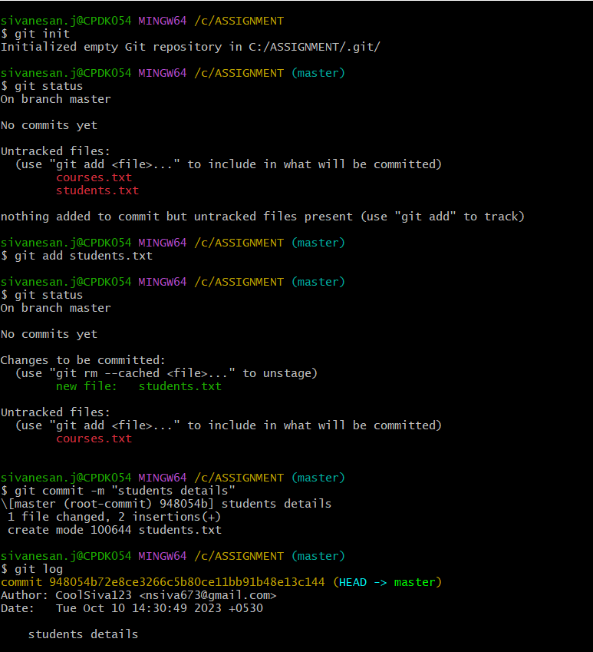

STEP 2 -- > UPDATE THE STUDENT FILES

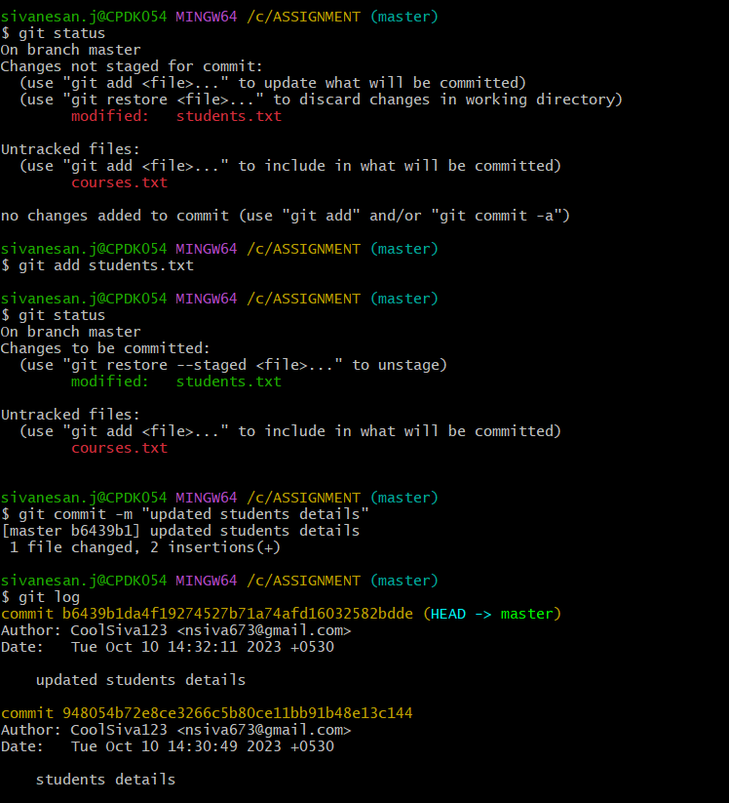

STEP 3 -- > UPDATE AND ADD STUDENT FILES

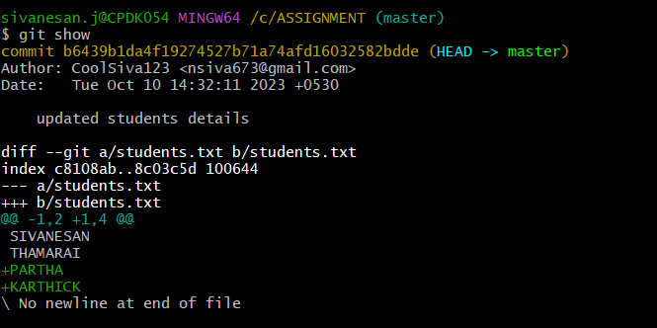

STEP 4 -- > SHOW THE DIFFERENCE B/W COMMIT

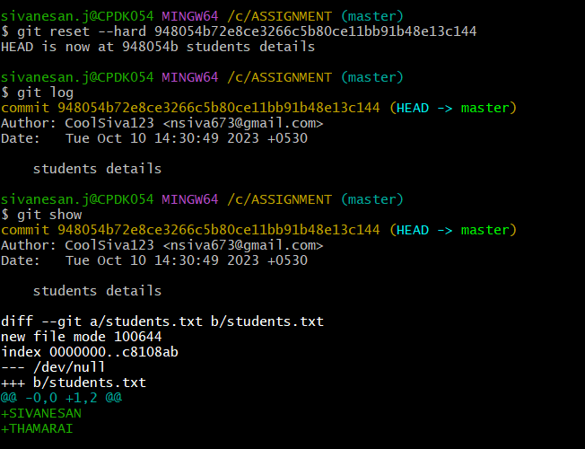

STEP 5 -- > CHECKOUT THE BRANCHES

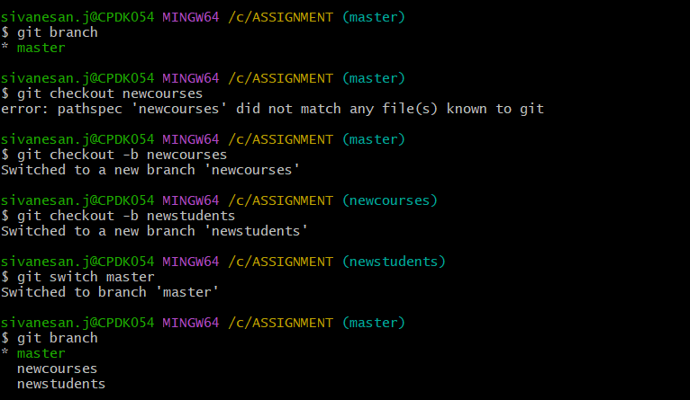

STEP 6 -- > HARD ASSET MAKE TO REPOSITORY CODE TO INITIAL ONE

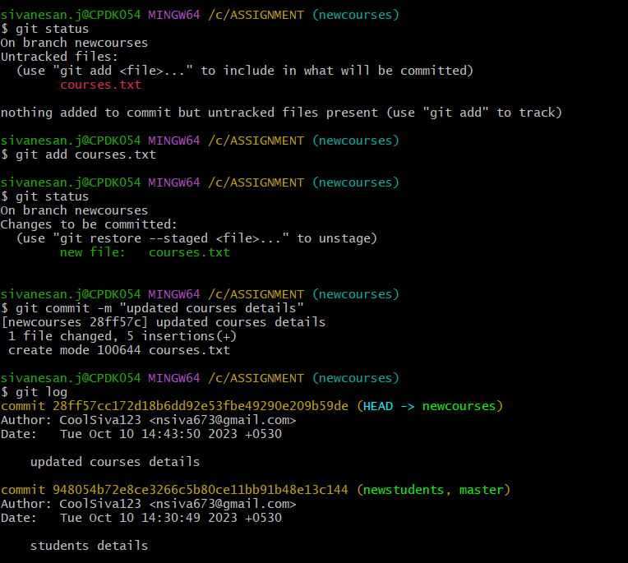

STEP 7 -- > HARD COMMIT CHANGED TO STUDENT FILE TO ORIGINAL ONE

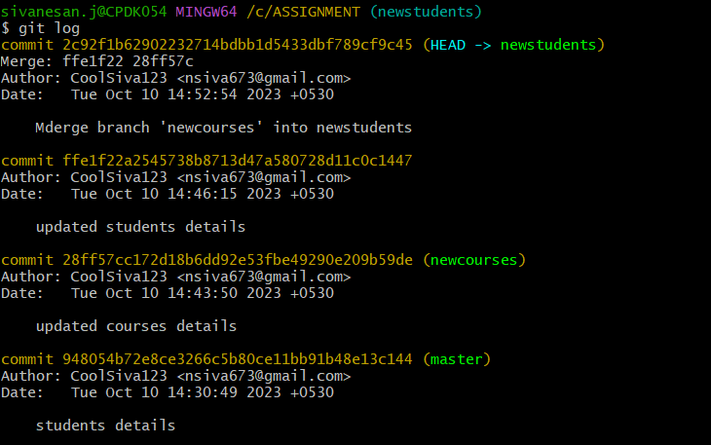

STEP 8 -- > MERGE THE NEWCOURSES AND NEWSTUDENTS IN MASTER

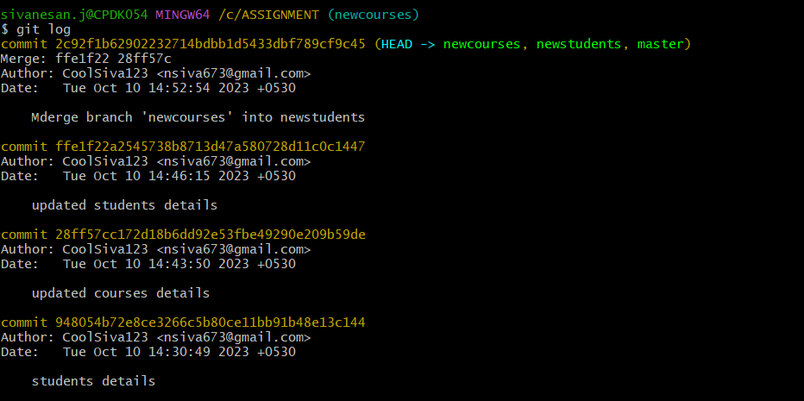

STEP 9 -- > ADD NEWCOURSES AND NEWSTUDENTS

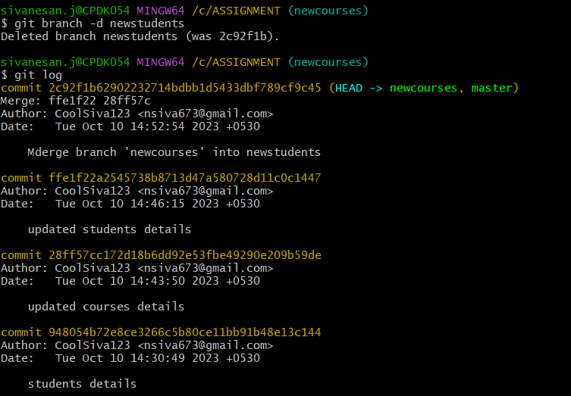

STEP 10 -- > REMOVE THE BRANCH NEWCOURSES AND NEWSTUDENTS

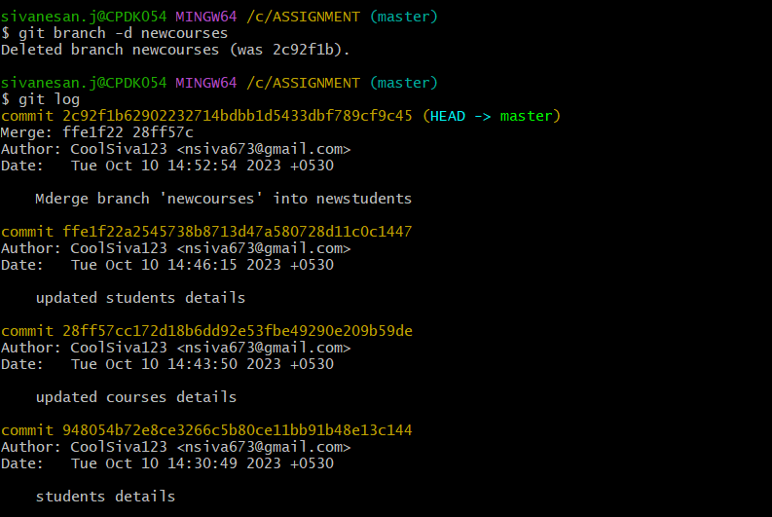

STEP 11 -- > REMOTE LINK WITH GITHUB ACCOUNT

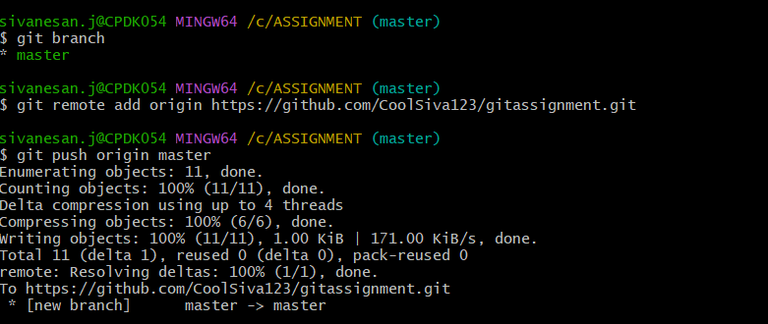

STEP 12 -- > PUSH THE CHANGES INTO GITHUB REPOSITORY

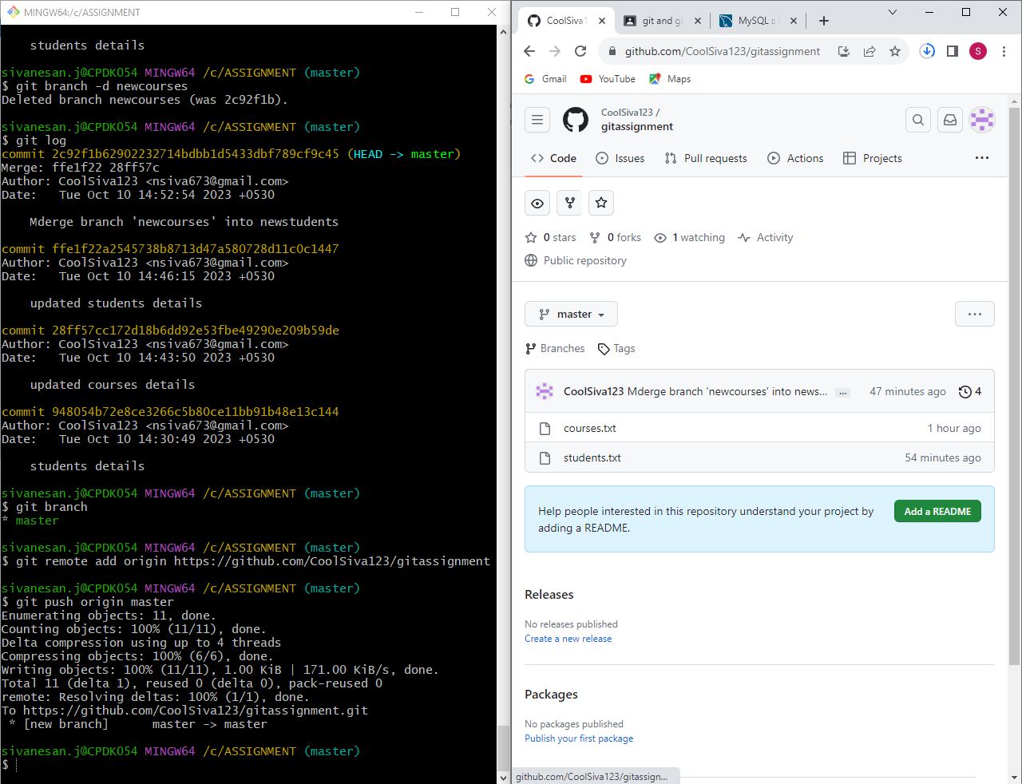

STEP 13 -- > CREATE FOLDER AND PULL COMMAND TO GET REMOTE FROM GITHUB

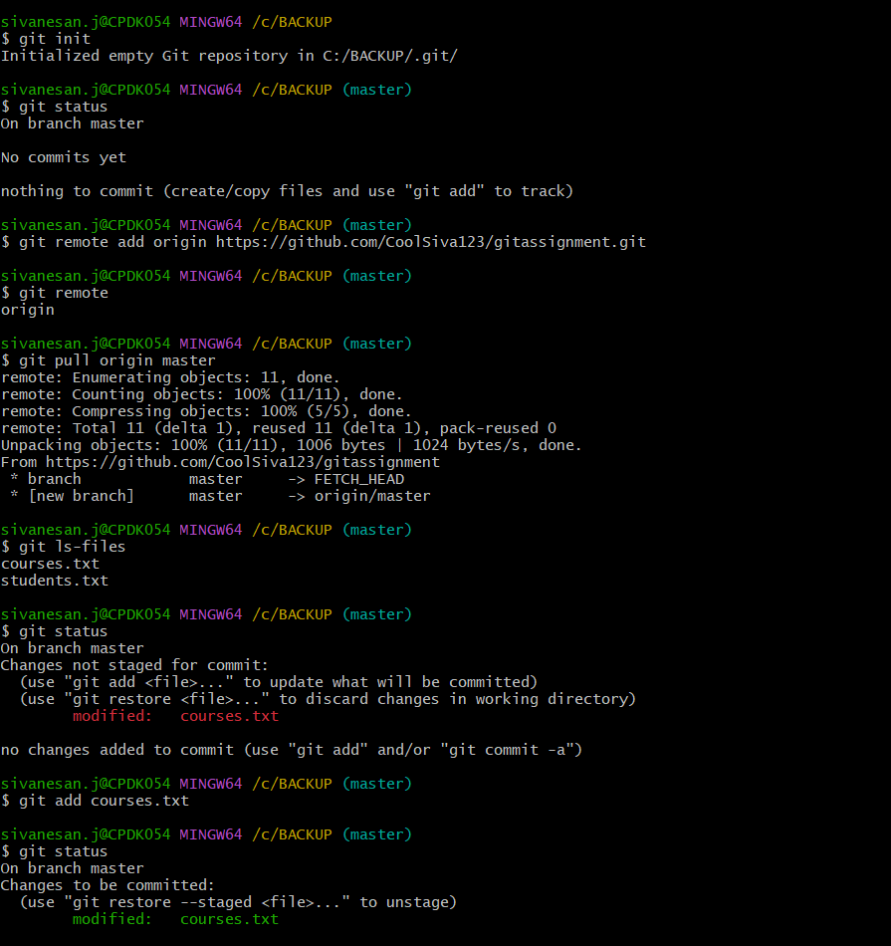

STEP 14 -- > ADD AND COMMIT THE LOCAL TO GITHUB

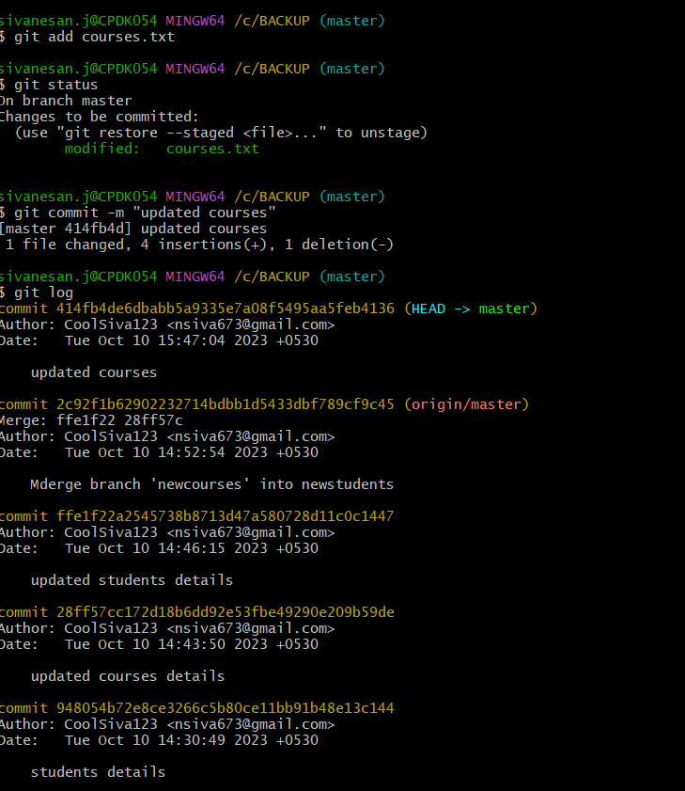

STEP 15 -- > PUSH COMMAND TO GITHUB REPOSITORY

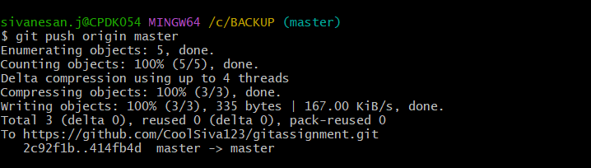

STEP 16 -- > OBSERVE AND PUSH BACK TO GITHUB REPOSITORY

